Premium Subscription Prediction System for Spotify Users
Name: Vipin Thingalaya
Date: 6/12/25

Executive Summary
This project builds a machine learning classification system that predicts whether a Spotify user is likely to purchase a Premium subscription. Using behavioural and preference-based survey data, the system identifies patterns that influence premium adoption and provides actionable insights for marketing teams.
Three models were developed: Logistic Regression, Random Forest, and XGBoost.
Based on performance and saved models in the environment, Random Forest was selected as the final model.
The model achieved 94% accuracy, meaning it can reliably identify both potential premium subscribers and non-subscribers.
The final deliverables include the trained model, cleaned dataset, analysis, visualizations, and a business-focused interpretation.

1. Introduction
The objective of this project is to analyse Spotify user behaviour and predict Premium subscription likelihood. This allows Spotify (or any music platform) to:
- Identify likely premium subscribers
- Reduce churn among reluctant users
- Personalize marketing campaigns
- Improve product experience through data-driven insights
The project uses a survey dataset with demographic, musical habits, device preferences, and satisfaction-based inputs.

2. Dataset Overview
Dataset Shape:
- 520 users
- 20 original columns
Target Column:
premium_sub_willingness, converted into binary:
Value | Meaning | Target Label
Yes | User will buy Premium | 0
No / Maybe / Not Sure | User will NOT buy Premium | 1
Features include:
- Age
- Listening device
- Preferred music genre
- Podcast habits
- Premium plan preferences
- Usage duration
- Satisfaction ratings
3. Data Preparation
The following steps were performed:
Missing value handling
- Numeric → median
- Categoric → mode
Encoding
All 19 categorical columns were converted using One-Hot Encoding, producing 100+ usable ML features.
Target cleaning
Values standardized to lowercase and mapped into 0 or 1.
Saving processed dataset
Final dataset saved as:
spotify_cleaned.csv

4. Model Development
Models trained:
- Logistic Regression (baseline)
- Random Forest (selected as best performing model)
- XGBoost
Train-test split:
- 80% training
- 20% testing
- Stratified sampling ensured target class balance
Saved model:
best_model_RandomForest.pkl

5. Model Evaluation
The Random Forest model achieved:
- 94% Accuracy
- Excellent precision and recall
- Strong prediction capability for both classes
Here is your official Classification Report:
 | precision | recall | f1-score | support
0 (Will Buy Premium) | 0.92 | 0.92 | 0.92 | 186
1 (Will Not Buy) | 0.96 | 0.96 | 0.96 | 334

Overall Accuracy = 0.94

6. Visualizations & Insights
6.1 Confusion Matrix
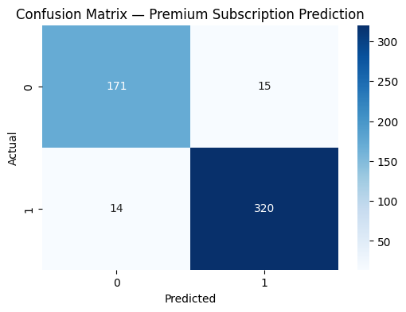
Interpretation:
- 171 users correctly identified as Premium buyers
- 320 correctly identified as non-buyers
- Very few misclassifications
This indicates excellent model reliability.

6.2 Probability Distribution Plot
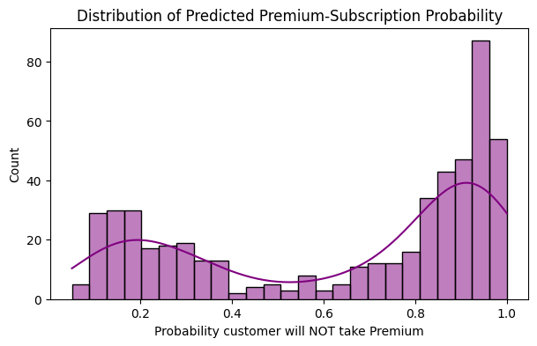
Interpretation:
- Users near 0 → strong premium likelihood
- Users near 1 → strong non-premium likelihood
- Mid-range probabilities (0.4–0.6) represent the best marketing targets
This distribution shows a meaningful separation of user intentions.

6.3 Feature Importance (Random Forest)
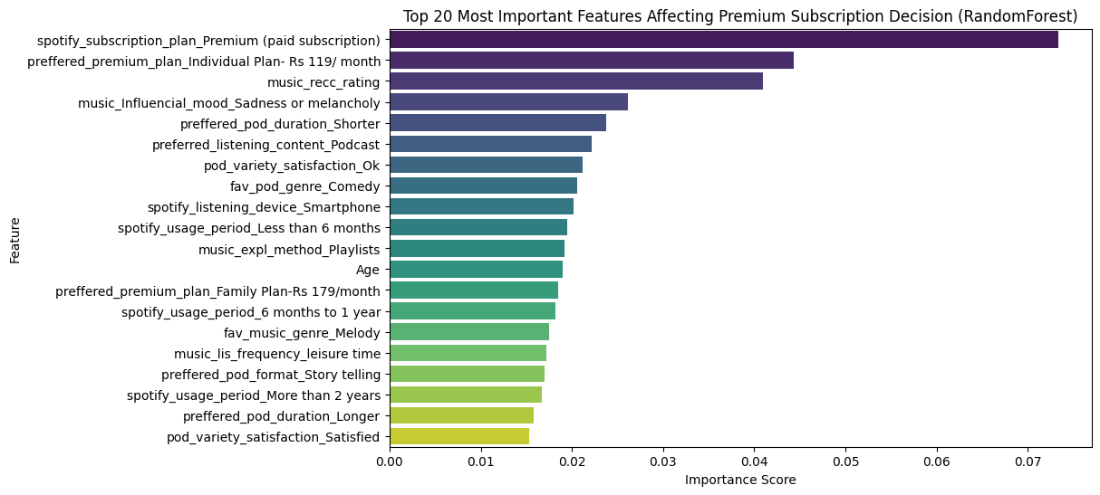Interpretation of top factors:
- spotify_subscription_plan_Premium (paid subscription)
- preferred_premium_plan_Individual Rs 119
- music_recc_rating (recommendation satisfaction)
- music_Influencial_mood_Sadness or melancholy
- Preferred podcast duration
- Listening device: Smartphone
- Usage period
These are the strongest determinants of Premium purchase behaviour.

7. Key Insights From the Model
Insight 1: Premium Plan Preference Predicts Conversion
Users who already know which plan they want are highly likely to purchase Premium.
Insight 2: Satisfaction Drives Premium Adoption
Higher music recommendation ratings → higher Premium upgrade likelihood.
Insight 3: Listening Device Matters
Smartphone listeners are more likely to become premium users than TV/speaker listeners.
Insight 4: Emotional Music Influence
Users whose listening is influenced by mood are more invested → higher subscription probability.
Insight 5: Long-term users are more likely to convert
Users who have used Spotify >6 months show stronger premium adoption patterns.

8. User Segmentation (Based on Predicted Probability)
Segment A (0.00–0.30) — High Premium Likelihood
- Strong engagement
- Moderate marketing needed
Segment B (0.30–0.60) — Medium Likelihood
Best segment for marketing
- Offer trials, discounts, student plans
Segment C (0.60–1.00) — Low Likelihood
- Require product improvements, not ads
- Low satisfaction group

9. Business Recommendations
Improve Music Recommendation Engine
Directly linked to higher Premium conversion.
Focus Advertising on Mid-Probability Users
They are the most influenceable.
Create Device-Specific Offers
Smartphone users respond best to Premium campaigns.
Personalize Content for Low-Engagement Users
Boosting engagement can shift them into Segment A.
Promote Genre & Mood-Based Premium Features
Great for users influenced by emotional or genre-based listening.

10. Deliverables Included
Project folder contains:
- spotify_cleaned.csv
- best_model_RandomForest.pkl
- scaler.pkl
- feature_importance_top20.csv
- test_set_predictions.csv
- All visual outputs

11. Tools & Technologies Used
- Python
- Pandas, NumPy
- Scikit-learn
- Random Forest Classifier
- Matplotlib, Seaborn
- Google Colab
- Joblib for model saving

12. Conclusion
This project successfully built a predictive system that identifies Spotify users likely to purchase a Premium subscription. The Random Forest model provides 94% accuracy, and feature insights highlight the behavioural and satisfaction factors that drive subscription intent.
The resulting system is a strong foundation for:
- Marketing automation
- User segmentation
- Business decision-making
- Product improvement strategy

